Date of investigation
Date of incident
Outcome
Action Taken
Reporting Tool
Attack Vector (Web, Email, Network, etc…)
Source IP/ Email
Source port
Destination IP/ Email
Destination port
Narrative
- Alerted by Snort
  - ET
  - ET
  - ET
- located source/ destination ip
  - src/prt:
  - dst/prt:
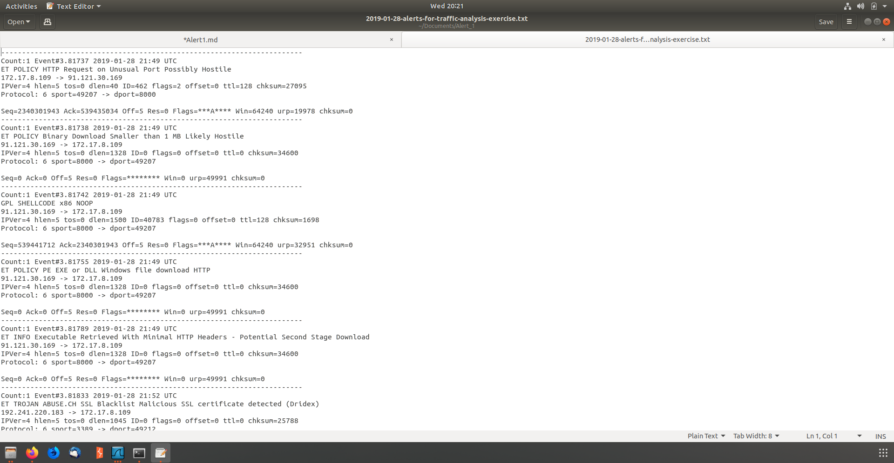
- identified hostname and MACAddress of infected computer
  - MAC:
  - Host name:
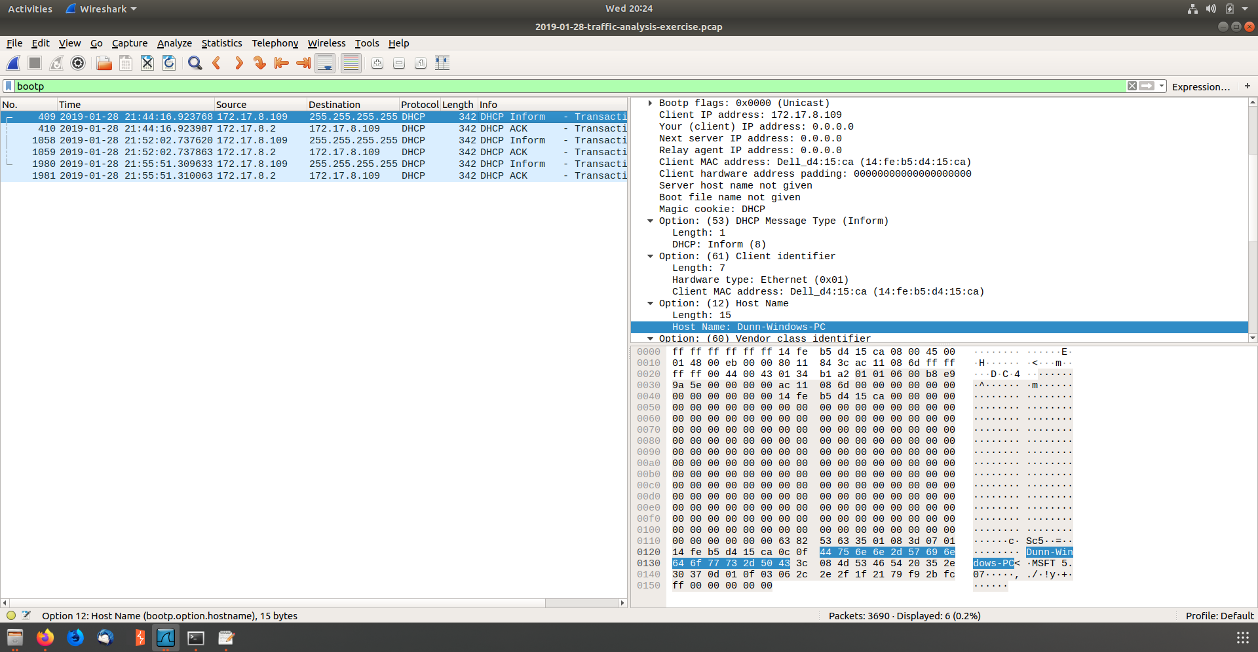
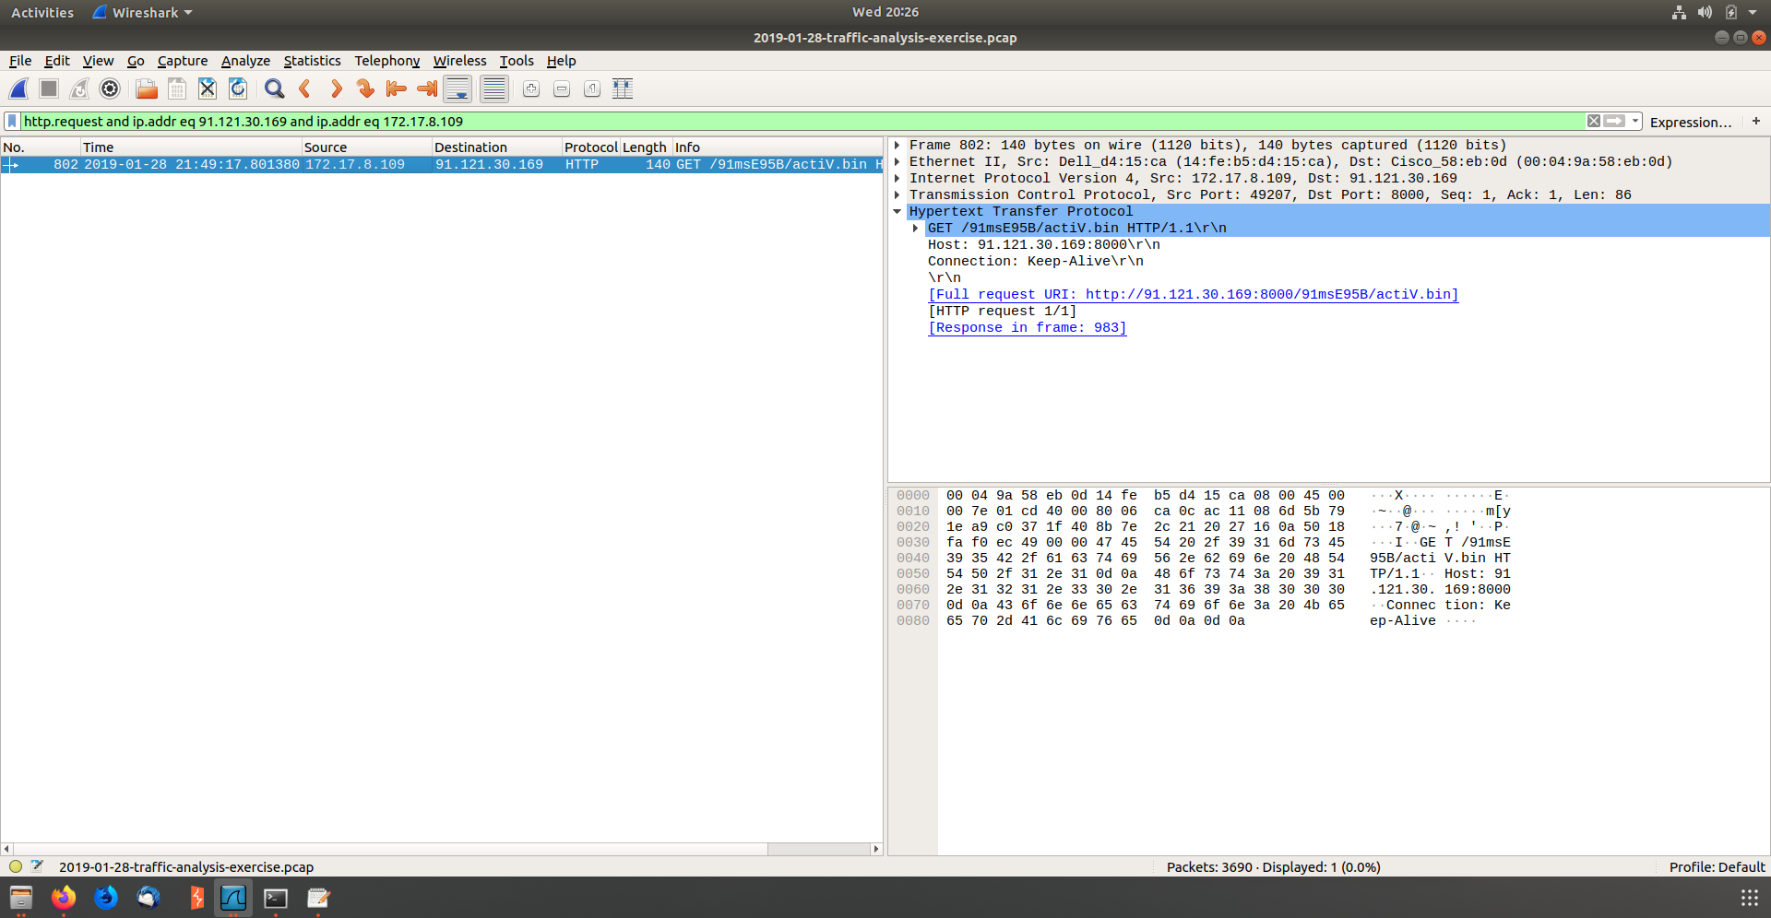
- Identified the time that the attack took place

- Followed the TCP and found was downloaded

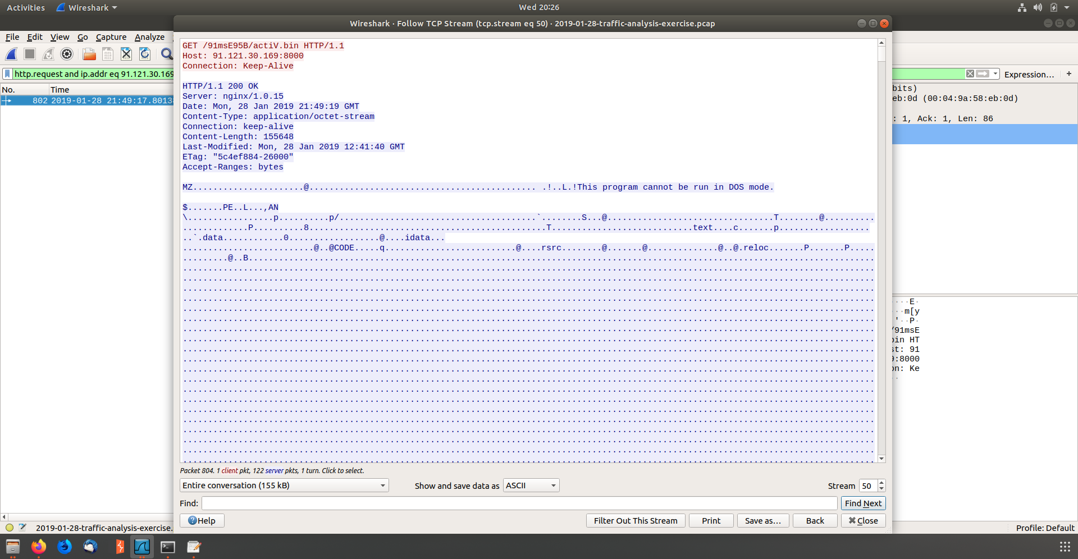
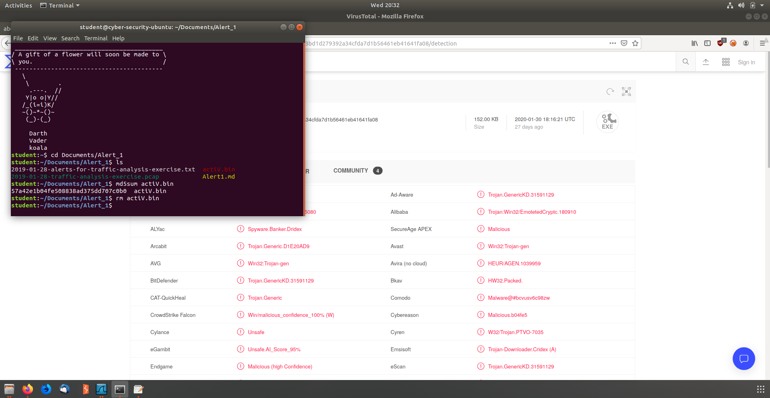
- Exported HTTP Objects and Hashed
  - Md5sum hash:
- Uploaded the Hash to virus total and found 57 engines detected the file
